**CHAPTER 4**

4.1 System design

System design has to do with the process of defining the architecture, component, modules, interfaces, and data for a system to satisfy specific requirements. It is the application of systems theory to produce development. System Design is preceded by system analysis. Because it is impossible to provide a precise definition between requirements elicitation and system system design, there is need to analyze a system in advance to identify what the real problem is, establish a gap and design a High Level Model to be exploded at the design stage.

**4.3 The Control Center**

The control center coordinates the behavior of the data such as data capture, appendage editing, browsing, deleting and report generation. The control center is found in fig.4.1. it is the exploded version of the High Level Model(HLM) in chapter 3.

start

Authentication

Main Menu

Select Option

Registration

Update record

Checking of project

Assignment of Project

Generate Report

Exit

Name

Matric No

department

Year of Project

Project Topic

Upload Project

Name

Matric No

department

Year of Project

Project Topic

Upload Project

New Project

Old Project

Project Topic

SQL Command

Document Title

**Figure 4.1 Exploded diagram of the high level model**

**4.3 Algorithm for each item on the control center**

**Do registration.prg**

**If button click = registration**

**Show registration jframe**

**If button click = register**

**Store userdata into proofread database into registration table**

**End registration.prg**

**Do Update records.prg**

**If button click = update**

**Show update jframe**

**If button click = update**

**Store modify registration table based on matric number**

**End update records.prg**

**Do checking of project.prg**

**If button click = checking of project**

**Show check project jframe**

**If button click = check**

**Compare stored project in registration table with user input project**

**If the store project topic equals the user input project topic**

**Display lines where equality occured**

**End checking project.prg**

**Do Assignment of project.prg**

**If button click = Assignment of project**

**Show assign project jframe**

**If button click = check**

**Compare stored project in registration table with user input project**

**If the store project topic equals the user input project topic**

**Display “this project has been taken”**

**Else display “this project has not been taken”**

**End assignment of project.prg**

**Do generate report.prg**

**If button click = generate report**

**Show generate report jframe**

**If button click = generate report**

**Execute input SQL Command and display result in jtable**

**End checking project.prg**

**Do login.prg**

**If button click = login**

**If username equals username from query from database**

**And password equals password from query from database**

**Display main menu frame**

**End login.prg**

**4.4 Database specification**

**Registration.dbf**

**Table 4.1 table structure of registration data**

|  |  |  |  |  |
| --- | --- | --- | --- | --- |
| Field name | Character type | length | Null | index |
| Name | char | 25 | no |  |
| Matricno | date | 10 | no | Primary key |
| department | char | 15 | no |  |
| Year_of_project | char | 10 | no |  |
| projecttopic | char | 10 | no |  |
| project | char | 05 | no |  |

Login.dbf

|  |  |  |  |
| --- | --- | --- | --- |
| field | Data type | size | null |
| username | varchar | 10 | no |
| password | varchar | 10 | no |

**4.5 Program module specification**

**1. main.prg- This controls the control center or menu**

**2 registration.prg – controls the registration or inputting of the user data into the database.**

**3 update.prg- handles the details of correcting data already existing in the database to reflect a new change.**

**4 login.prg- handles details of login to the main menu**

**5 generate report.prg- provides a means for the user to generate report through queries to the database**

**6 Assignment of project.prg- provides a means for the user to check if a project topic has been taken before.**

**7 checking of project.prg- provides a means for the user to compare two project documents so as to determine where one was copied from the other.**

**4.6 Input/Output specifications**

Inputs has to do with what is going into the database. Output refers to what the program will produce as output such as reports.

**Registration Data**

**Table 4.4 Structure of input format for registration data**

|  |  |
| --- | --- |
| Name |  |
| Matric no |  |
| Department |  |
| Year of project |  |
| Project topic |  |
| Upload project |  |

**Input of update Data**

**Table 4.5 Structure of input format for forensic data**

|  |  |
| --- | --- |
| Name |  |
| Matric no |  |
| Department |  |
| Year of project |  |
| Project topic |  |
| Upload project |  |

**OUTPUT FORMATS**

**Report of all data in the registration table**

|  |  |  |  |  |  |
| --- | --- | --- | --- | --- | --- |
| **name** | **Matric no** | **department** | **Year of project** | **Project topic** | **Upload project** |
| **kkkkk** | **05/0000** | **xxxx** | **Sep,5,1986** | **xxxx** | **xxxxx** |
| **xxxx** | **05/44444** | **xxxx** | **Sep,4,1996** | **xxxx** | **xxxxx** |

**Figure 4.6 structure of the output format for the report generation**

**4.7 Overall dataflow diagram**

Student project details registration

Update date for corrective registration

Process

report

Print out report

database

Database

Figure 4.2 overall dataflow diagram

4.8 **Data Dictionary**

Student Name: Abbreviated NAME includes First Name + Middle name+Surname. Intended to identify the real name of the student that did the project.

Matriculation number: abbreviated matric no used to uniquely identify a student in the system.

Department: the department the student graduated from.

Year of project: year the student did the project same as the year of graduation

Project topic: The project topic or project title of the student

Upload project: stipulates actual project document of the student

4.9 Choice and Justification of programming language used: The programming language used is JAVA. Java is used because going by the unique nature of the requirement of this project which has to do with the comparism of two documents to find out if one was copied from the other, there is no doubt that we are faced with string manipulation, and JAVA is known for its excellence in handling strings.

**4.10** **system documentation and implementation**

In this chapter I intend to explain more elaborately the hardware and software requirements for effective implementation of the software.

**4.10.1 Hardware Requirement:**

This software requires at least 3GB of Ram and 250GB of hard disk . A processor speed of at least 2.67GHZ is ideal.

* + 1. **How to Install:**

The finished application is in the form of a Java Archive (JAR) file. It does not require any installation as is the practice with other conventional softwares, Just place the dist folder (that is the folder containing it) in a convenient location and place the shortcut to it on the desktop.

**4.10.3 How to Use the Software:**

To successfully use this software the mysql Database Management System must be installed in the computer and a database with the name “proofread” created note that during installation of the mysql database is show in the images:

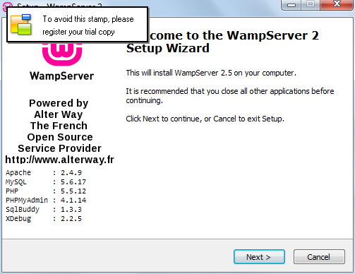

Figure 4.3 welcome screen of wamp server installation

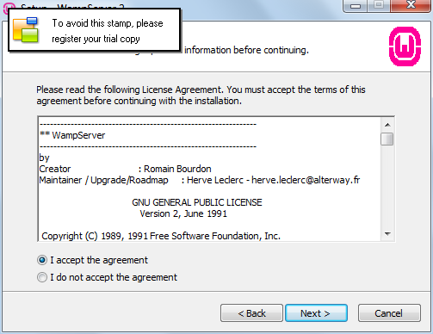

Figure 4.4 wamp server acceptance screen

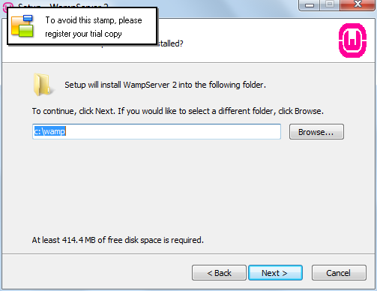

Figure 4.5 folder selection

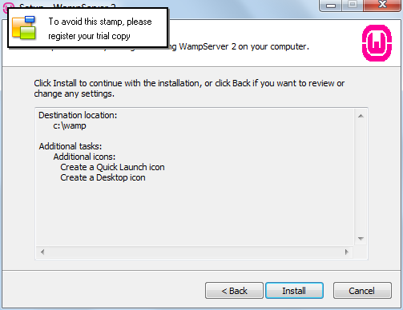

Figure 4.6 installation screen

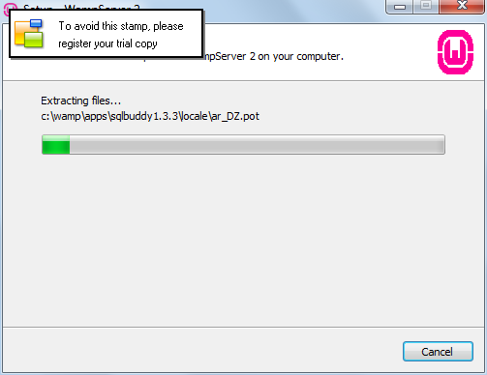

Figure 4.7 progress screen

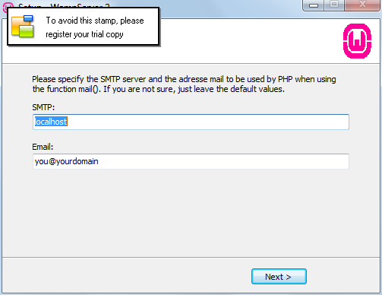

Figure 4.7 SMTP server setting

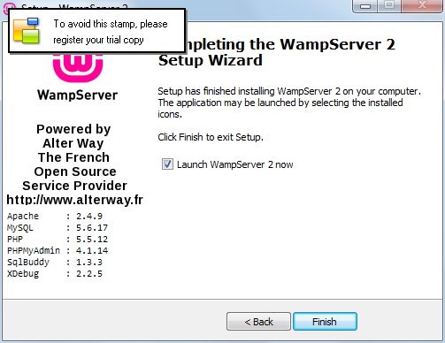

Figure 4.8 server completion

* + 1. **Training Users:**

Once you see the login dialog just select one of the ports and click the test button for connectivity if connection is successful then you can now input username and password to login, the main form is displayed there after.

**4.10 Convertion from the present system:**

A system conversion can be done in any of the following ways:

1. **parallel conversion**

A type of conversion in which both new and old system operate together for a period of time. It is the safest type of conversion. The results of both systems are compared. The old system can be used until all problems in the new system are removed.

. **pilot conversion**

In this type of conversion, one part of the organization uses the new system and the rest of the organization uses the old system. When one part of the organization is satisfied with the new system, the rest of the organization can start using it.

1. **phase conversion**

a type of conversion in which individual components of new system are implemented one by one is called phase conversion.

1. **direct conversion**

in this type of conversion, the old system is directly replaced by the new system. It is the most risky conversion. It may be necessary when time is very short.this one is also called crash conversion.

The convertion procedure that will be adopted will be parallel, the manual system will be used along side the automated system until all documents in paper are input into the database this has to be a gradual process, and when all unforeseen problems in this software are identified and corrected.